CIS530 HW4: Submission Example

5. Free-response Questions (10 points)

Results
- Task: The fourth column of will_play_text.csv contains the name of the character who spoke each line. Using the methods described above, *which characters are most similar? Least similar? *
- Results
  - In the play “Henry IV”, the most similar characters are FALSTAFF and PRINCE HENRY. The least similar characters are Thieves, SIR WALTER BLUNT
- Discussion
I have used 3 similarity methods (cosine similarity, jaccard similarity, dice similarity) to run the similar check for the characters in Henry IV play. For the most similar characters, the 3 methods all gave the same answer. FALSTAFF and PRINCE HENRY both represents contrasting ideas of honor, leadership, and maturity. That’s why the words they use could have most similarity. Under cosine similarity, the similarity score is high as 0.9334344176164313 (1 means the same). For the least similar pairs, the 3 methods also gave the same answer: Thieves and SIR WALTER BLUNT. SIR WALTER BLUNT is a noble knight. He represents completely different from thieves. So far, the performance between 3 similarity methods is the same. But from the score with different methods are different. The cosine similarity has highest similarity scores overall take 0.9334344176164313 as an example, the same pair has 0.6248453117563065 in dice similarity method and 0.45438183580229824 in jaccard similarity.
Based on the observation, the cosine similarity method tends to have higher score and jaccard similarity tends to have lowest score.

Extra Credit (15 points)

Results
- Explanation
- The experiment I did is to use both term to document matrix and context matrix.
- When using term to document matrix, I used cosine similarity method, Jac card similarity method and dice similarity method.
- When using context matrix, I also applied similarity method, Jac card similarity method and dice similarity
- When generate term-to-document matrix, and context matrix, I only used the words showed in Sim999.txt
- Results
  - The Sim999.txt has 1028 words.
  - The shape of term-document matrix is 1028x36
  - The shape of context document matrix is 1028x1028
For term_to_doc_matrix
Matrix Type | Similarity Method | Calculated Correlation
TF_IDF matrix | Similarity Method | -0.042450838943562275
TF_IDF matrix | Cosine similarity | -0.02028911744438534
TF_IDF matrix | Jaccard similarity | -0.02028911744438534c

For term context matrix without using PPMI
Context Window Size | Cosine Sim | Jaccard Sim | Dice Sim
1 | -0.05819418 | 0.015818536 | 0.015818536
2 | -0.078344083 | -0.040023336 | -0.040023336
3 | -0.081037121 | -0.049540543 | -0.049540543
4 | -0.072660238 | -0.046024354 | -0.046024354
5 | -0.078471704 | -0.05447142 | -0.05447142
6 | -0.090222029 | -0.068305526 | -0.068305526
7 | -0.092299013 | -0.073112192 | -0.073112192
8 | -0.092164871 | -0.072227079 | -0.072227079
9 | -0.092025334 | -0.072230931 | -0.072230931
10 | -0.092989052 | -0.073477924 | -0.073477924
11 | -0.092600939 | -0.07291668 | -0.07291668
12 | -0.092507636 | -0.072859943 | -0.072859943
13 | -0.091782585 | -0.071967962 | -0.071967962
14 | -0.091734707 | -0.07185668 | -0.07185668
15 | -0.091734707 | -0.071921152 | -0.071921152
16 | -0.09170598 | -0.071849677 | -0.071849677
17 | -0.091744283 | -0.071808798 | -0.071808798
18 | -0.091615011 | -0.071777034 | -0.071777034
19 | -0.091581497 | -0.071765238 | -0.071765238
20 | -0.091557557 | -0.07178164 | -0.07178164
21 | -0.09159586 | -0.071779243 | -0.071779243

For term context matrix with using PPMI, the correlation between the similarity method and Sim999 data set
Context Window Size | Cosine Sim | Jaccard Sim | Dice Sim
1 | 0.072303852 | 0.04705001 | 0.04705011 | The best value
2 | 0.064690925 | 0.03533272 | 0.03533272
3 | 0.057892787 | 0.02565632 | 0.02565632
4 | 0.050686566 | 0.01751899 | 0.01751899
5 | 0.05201825 | 0.01681684 | 0.01681684
7 | 0.051907771 | 0.01387027 | 0.01387027
8 | 0.051579796 | 0.01198453 | 0.01198453
9 | 0.052379867 | 0.01447365 | 0.01447365
10 | 0.05281895 | 0.0141957 | 0.0141957
11 | 0.052939799 | 0.01478383 | 0.01478383
12 | 0.052935771 | 0.01485634 | 0.01485634
13 | 0.052754498 | 0.01474354 | 0.01474354
14 | 0.052645734 | 0.01466298 | 0.01466298
15 | 0.052267075 | 0.0143528 | 0.0143528
16 | 0.051410499 | 0.01398662 | 0.01398662
17 | 0.051539408 | 0.01399468 | 0.01399468
18 | 0.051591777 | 0.01391411 | 0.01391411
19 | 0.051611919 | 0.013898 | 0.013898
20 | 0.051648175 | 0.01400273 | 0.01400273
21 | 0.051716658 | 0.01412359 | 0.01412359
22 | 0.051491067 | 0.01391814 | 0.01391814

For term context matrix, the context window size and similarity method relationship.
The following is the context window size VS 3 different similarity’s correlation to the Sim999.txt
The following setup gave highest correlation:
Context Window Size = 1
Similarity Method: Cosine Sim
Highest correlation score: 0.072303852
Method: Apply PPMI on the context windows
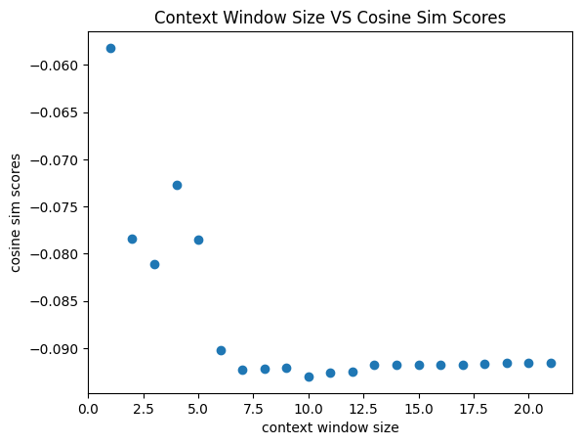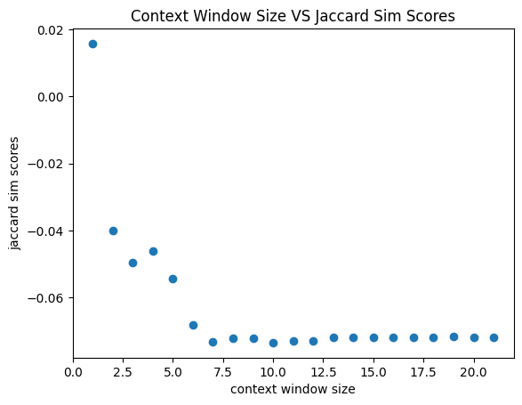
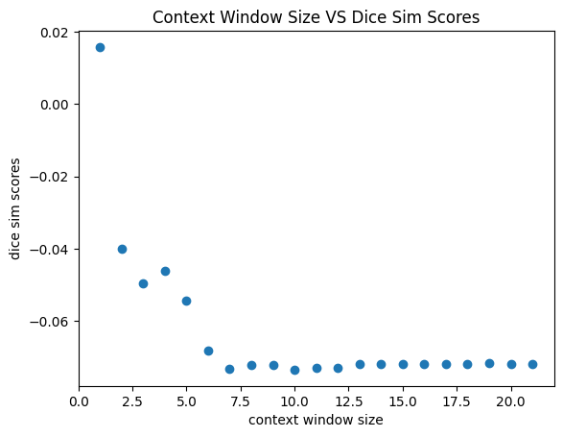
The following is the context window size VS 3 similarity method
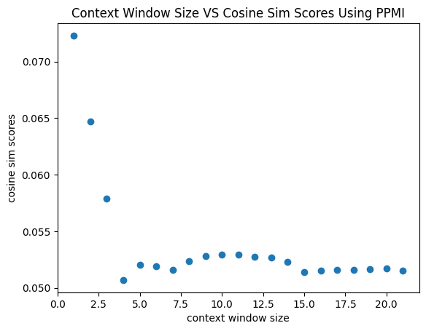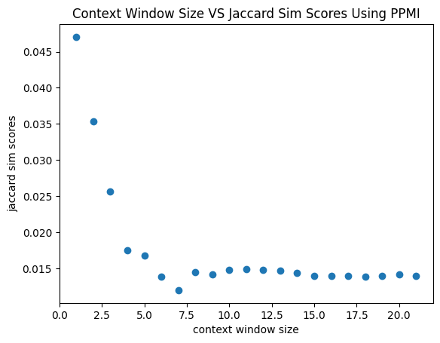
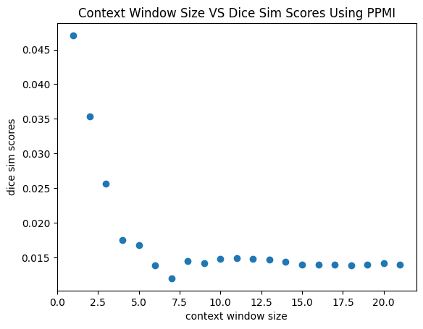
- Discussion
Based on the experiments, I noticed that the correlation is low for tf-idf matrix and term-context matrix when there’s no PPMI applied. The PPMI step is very necessary.
Why the correlation is low is because there are 224 words in Sim999 but not in Shakespeare’s play. These missing words will lead to low correlation rate.

